NEW A130 Dis-Eur-Czech Rep.-Moravia-Dolní Věstonice-Figurine-Abstract-26,000 BP

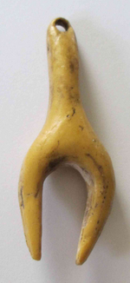 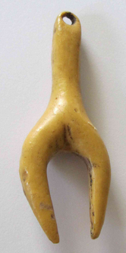

Figs. 1-2. Resin copy of the original figurine, carved from mammoth ivory.

**Formal Label:** Czech Rep.-Moravia-Dolní Věstonice-Figurine-Abstract-26,000 BP

**Display Description:** This provocative carving from mammoth ivory in the curious form of a bird’s wish bone has been hypothetically identified as a symbolic female anthropomorph’s lower body with the wide-spaced appendages supposedly those of a woman’s pelvis and legs. Hence, this carving has been called a Venus figurine. It comes from one of the most famous Moravian sites, Dolni Vestonice, situated on the hill of Pollau at 549 m asl (1,801 ft). This site was excavated in the 1920s and again in 1947-52 (Klima 1963), and it has been a source of artifacts of the Gravettian period (27,000-20,000 BP). Remains of molluscs, spruce and pollen from the site suggest that it was occupied during a cold climate with a tundra environment.

**Accession Number: A130**

**LC Classification:** GN772.22.C95

**Date or Time Horizon:** 26,000 BP C14.

**Geographical Area:** Czech Republic, Dolní Věstonice, Moravia, at the base of the hill of Pollau.

**Map, GPS Coodinates**: 48.88822 16.64369, 40° 26' 46" N 79° 58' 56" W

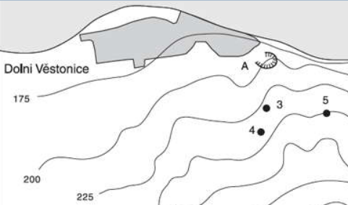

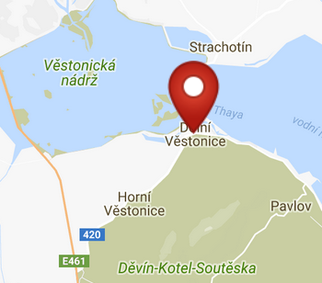 

Fig. 3. Map of the location of Dolní Věstonice sites. Key: 3. Dolní Věstonice II; 4. Dolní Věstonice II-A; 5. Dolní Věstonice III; A. Dolní Věstonice source of stone. From Verpoorte 2000.

Figs. 4-5. Maps of the location of Dolní Věstonice from http://latitude.to/img/latitude-logo.svg.

**Cultural Affiliation:** Gravettian Period (27,000-20,000 BP)

**Medium:** mammoth ivory

**Dimensions:   
Weight: original, unknown.**

**Provenance: Moravian Museum, Brno.**

**Condition:** museum replica in resin.

**Discussion:** Dolní Věstonice, Moravia, in the Czech Republic, is on the hill of Pollau 549 m (1,801 ft), dating to approximately 26,000 BP. The site has been a source of artifacts of the Gravettian period (27,000-20,000 BP). This ivory carving from a mammoth tusk exhibits a rare look at abstract art based on the bipedal nature of humans. However, the wide-spaced appendages suggest that this is, indeed, a female since it has the pelvic structure able to be involved in childbirth. Hence, this figurine has been styled a “Venus” figurine based on this morphology. It is also notable that this figurine has a hole in its upright post, perhaps in order to have it suspended around the neck. Therefore, if it were worn on the body by a nubile woman it probably was believed to have had the power to ensure a safe childbirth.

**References:**

Klima, B. 1963. *Dolni Vestonice. Erforschung eine Lagenplatzes der Mammutjager an der Jahren 1947-52* Monum. Archaeol., XI.

Trinkaus, Erik and Jiri Svoboda (Eds.) 2005.*Early Modern Human Evolution in Central Europe: The People of Dolní Vestonice and Pavlov* (Human Evolution Series). New York: Oxford University Press.

Verpoorte, A**.** 2000. *Camps, boundaries and art*, https://openaccess.leidenuniv.nl/bitstream/handle/1887/13512/ASLU08_09.pdf